Watch Out for That Volcano!

Jan McConnell
janmcconnell@cityuniversity.edu
Master of Science, Data Science

Kimberly Thomas
kstbet@cityuniversity.edu
Master of Science, Data Science

Cuong Vo
vocuong@cityuniversity.edu
Master of Science, Artificial Intelligence
DS520 Data Mining (Summer 2025-2026)
School of Technology and Computing
Cit University of Seattle
Seattle, WA 98121

Abstract

This project applies data mining techniques in R to analyze volcanic risk using global data from the Smithsonian Global Volcanism Program. The team explores three key questions: (1) Can a volcano’s physical characteristics, such as type, elevation, and tectonic setting, be used to predict whether it is likely to erupt explosively? (2) Can the Volcanic Explosivity Index (VEI) of a future eruption be estimated based on volcano traits and eruption history? (3) Which volcanoes have the highest historical eruption frequency, and what does this imply for hazard assessment? To address these questions, we built machine learning models for classification and regression. For the third question, we apply descriptive analytics to assess hazard based on eruption frequency.

Keywords: Explosive eruption prediction, Volcanic Explosivity Index (VEI), Eruption frequency, Volcanic hazard assessment, Data mining, Machine learning with R.

1. PROBLEM STATEMENT

Volcanic eruptions present risks to human life, infrastructure, and the environment. These risks depend on the physical characteristics of the volcano, the type and magnitude of its eruptions, and the population exposed to potential hazards. While many volcanoes have been studied individually, there is a need for data-driven, scalable approaches to assess eruption behavior and risk on a global scale. This project investigates whether machine learning techniques can be used to (1) predict the likelihood of an explosive eruption based on a volcano's physical features, (2) estimate the VEI of future eruptions based on eruption history and volcano traits, and (3) identify volcanoes with the highest historical eruption frequency to better understand patterns of volcanic activity and potential hazard implications. The goal is to develop predictive and analytical models that can support volcanic hazard assessment and preparedness planning.

2. DATASET SELECTION

This project uses data from the Smithsonian Institution’s Global Volcanism Program, specifically the Volcanoes of the World database (Version 5.2.8). Two datasets were extracted: the Holocene Volcano List, which contains geological and geographic attributes for over 1,500 volcanoes active within the last 10,000 years, and the Confirmed Eruptions dataset, which documents historical eruptions along with characteristics such as eruption type, VEI, and event timing. They were selected for their credibility, global coverage, and detailed attribute structure and include elevation, volcano type, tectonic setting, and proximity to population centers. The eruption records include magnitude, duration, and eruption style. Together, these datasets allow for predictive modeling and risk analysis across a variety of volcano types and global regions (Global Volcanism Program, 2024).

3. DATA CLEANING

Data preparation focused on resolving missing values, ensuring consistency across datasets, and preparing the data for modeling and analysis.

Q1: Explosive Eruption Classification
For the explosive eruption prediction, the VEI column in the eruption dataset was converted to a numeric type to support the creation of a binary target variable indicating whether an eruption was explosive (VEI ≥ 3). Rows with missing or ambiguous VEI values were excluded from further analysis. Volcano traits including elevation, type, and tectonic setting were extracted from the Holocene dataset, and rows with missing tectonic setting were removed. The two datasets were merged using Volcano_Number as the key, and one-hot encoding was applied to categorical variables before performing a stratified train-test split.

Q2: VEI Regression Modeling
Additional cleaning steps included filtering out eruptions without numeric VEI values, removing volcanoes missing elevation or tectonic setting information, and discarding duplicate records. Data was grouped by volcano, and mean values were computed for numeric predictors. This produced a modeling dataset with unique volcano entries and reliable trait data.

Q3: Eruption Frequency Profiling
Eruption counts were aggregated by volcano ID and merged with structural data from the Holocene list. Only volcanoes with matching entries in both datasets were retained. No additional filtering was required since the analysis was descriptive, based on the count of recorded eruptions.

Across all scripts, cleaning steps were kept minimal to preserve as much historical data as possible while maintaining the integrity and interpretability of the models. Common preprocessing functions included drop_na, left_join, and mutate, and all transformations were logged and summarized to confirm expected behavior.

4. DATA EXPLORATION AND ANALYSIS

Before modeling, each dataset was examined to understand key distributions, identify anomalies, and assess the relationship between volcano traits and eruption behavior.

Q1: Explosive Eruption Classification
The distribution of the VEI revealed that most eruptions fall between VEI 1 and 3, with fewer high-magnitude events. The target variable was defined as explosive (VEI ≥ 3) versus non-explosive (VEI < 3), resulting in a moderately imbalanced dataset. Exploratory summaries showed that explosive eruptions were more likely among stratovolcanoes and subduction zone settings, while lower VEI events occurred across a broader range of types and tectonic environments.

A summary of volcano types across the dataset reveals that stratovolcanoes, calderas, and shields are the most frequently recorded types. Stratovolcanoes are especially common, consistent with their association with subduction zones and explosive activity.

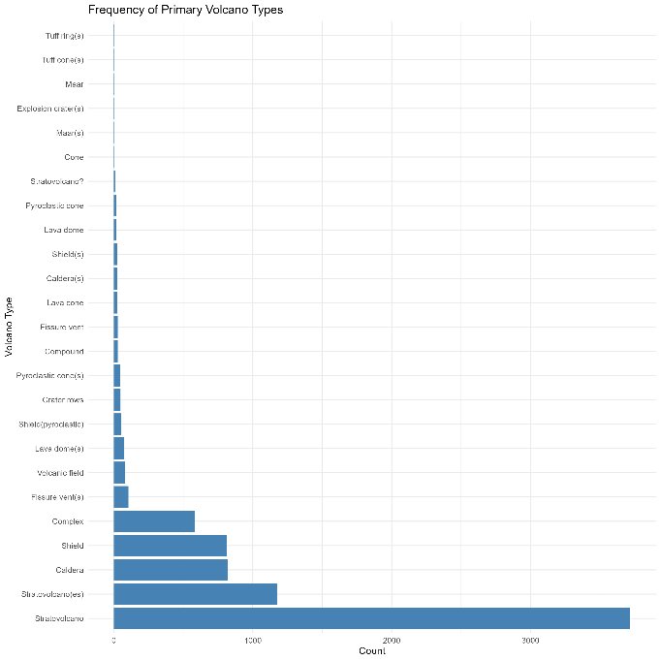
Figure 1: Count of volcanoes by primary volcano type.
Q2: VEI Regression Modeling
Numeric values of VEI were preserved to support continuous prediction. After removing missing values, VEI remained centered between 1.5 and 2.5, with very few extreme events above VEI 5. Predictor variables such as elevation and volcano type showed modest variation, but early results from linear modeling indicated that VEI is not well-explained by these traits alone. This suggested the need for more flexible modeling techniques to capture subtle nonlinear relationships.

Q3: Eruption Frequency Profiling
Volcanoes were grouped by Volcano_Number to count the number of confirmed eruptions on record. This produced a ranked list of historically active volcanoes, with several high-frequency systems located in Japan, Russia, and Indonesia. A horizontal bar chart was created to visualize the top ten volcanoes by eruption count. Although this analysis does not account for eruption magnitude or exposure, it highlights volcanic systems with sustained eruptive histories that may warrant increased monitoring.

Overall, these exploratory analyses informed model selection, highlighted potential feature importance, and provided context for interpreting the results of each modeling task.

5. MACHINE LEARNING METHOD SELECTION AND MODEL TRAINING

We used machine learning techniques in R to approach each question, choosing methods based on whether the task involved classification or regression, how the target variable was structured, and how easy it would be to interpret the results. This approach follows standard practices in supervised learning, as described by Bishop (2006).

Decision trees and ensemble techniques such as random forest are commonly used in data mining tasks due to their interpretability and adaptability (Han, Kamber, & Pei, 2011).

Among the models trained, logistic regression offered a baseline with high interpretability, while random forest provided improved flexibility and performance—consistent with their established roles in applied statistical learning (James, Witten, Hastie, & Tibshirani, 2021).

One-hot encoding was used to convert categorical features into a suitable format for modeling, following standard preprocessing steps in machine learning workflows (Lantz, 2023).

Grouping eruption records by volcano number is a form of data preprocessing commonly used in large-scale pattern mining (Leskovec, Rajaraman, & Ullman, 2020).

Q1: Explosive Eruption Classification
To predict whether a volcano is likely to erupt explosively, the VEI variable was converted to a binary response: explosive (VEI ≥ 3) or non-explosive (VEI < 3). Three supervised classification models were trained using volcano characteristics as predictors: logistic regression, decision tree, and random forest. Categorical predictors (e.g., volcano type, tectonic setting) were converted to dummy variables using one-hot encoding. The dataset was split into training (70 percent) and testing (30 percent) sets. Models were evaluated using accuracy, precision, recall, and F1 score. Random forest showed improved performance over the other models, suggesting that ensemble methods are more effective at capturing complex patterns in the data.

The dataset for explosive eruption prediction showed moderate imbalance, with non-explosive eruptions outnumbering explosive ones. This imbalance was addressed during model training using stratified splitting and, in later optimization, SMOTE sampling.

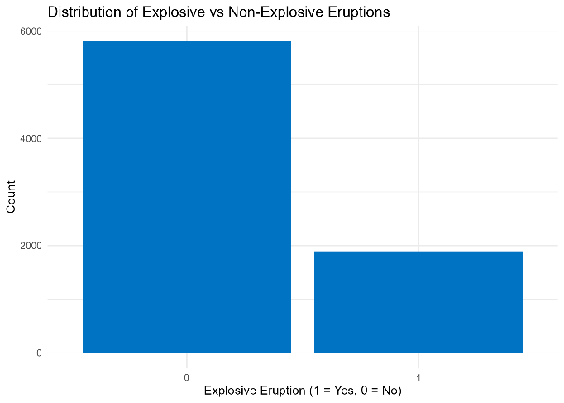
Figure 2: Class distribution of explosive (1) versus non-explosive (0) eruptions.
Q2: VEI Regression Modeling
For estimating the VEI of future eruptions, the problem was framed as a regression task. Predictor variables included volcano type, elevation, and tectonic setting. Three models were trained: linear regression, decision tree regression, and random forest regression. As with Q1, categorical variables were one-hot encoded. The dataset was split 70/30 for training and testing. Model performance was evaluated using RMSE (Root Mean Square Error), MAE (Mean Absolute Error), and R² (coefficient of determination). All models produced relatively low R² values, indicating limited predictive power. However, random forest achieved the lowest RMSE and MAE, suggesting it provided the best approximation within the limitations of the available features.

Q3: Eruption Frequency Profiling
The third question did not require supervised learning. Instead, it used a descriptive approach. Eruption counts were computed by grouping confirmed eruption records by volcano number. These counts were joined with volcano metadata to create a summary table. Volcanoes were ranked by total eruption count to identify historically active systems. While no machine learning model was trained for this question, the analysis supports hazard profiling by highlighting volcanoes with frequent activity over time.

Together, these modeling techniques demonstrate the use of classification, regression, and descriptive analytics to address distinct questions in volcanic risk assessment.

The source code for all models, data preparation scripts, and visualizations used in this project is publicly available on GitHub (McConnell, Thomas, & Vo, 2025).

6. MODEL EVALUATION

Each model was assessed using evaluation metrics appropriate to the problem type. The primary goal was not only to measure predictive performance but also to compare modeling approaches and understand their strengths and limitations given the available data.

Q1: Explosive Eruption Classification
Model performance was evaluated using accuracy, precision, recall, and F1 score on the testing set. The logistic regression model provided a reasonable baseline, but its ability to capture complex patterns was limited. The decision tree improved interpretability but showed signs of overfitting. The random forest model achieved the highest overall performance:

Model Acc Rec Pre F1
Logistic Regression 0.67 0.60 0.39 0.47
Decision Tree 0.76 0.64 0.50 0.56
Random Forest 0.80 0.65 0.60 0.62
Random Forest-2 0.77 0.70 0.80 0.76
XGBoost 0.80 0.66 0.62 0.64

These results indicate that the random forest model was better able to generalize from the training data, particularly in identifying true explosive eruptions. However, recall was slightly lower than precision, suggesting the model was more conservative in labeling eruptions as explosive.

The confusion matrix highlights the model’s classification performance on the test set, with most predictions concentrated along the diagonal. False negatives are more common than false positives, suggesting the model was conservative in labeling eruptions as explosive.

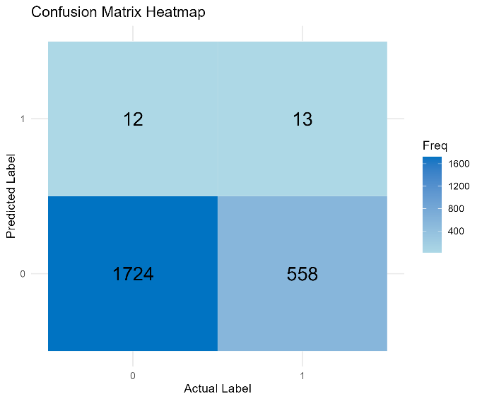
Figure 3: Confusion matrix of the random forest classification model.
Q2: VEI Regression Modeling
VEI regression models were assessed using three common metrics: RMSE, MAE, and R². All models struggled to explain substantial variance in VEI, suggesting that historical eruption size is not easily predicted from structural traits alone.

Model RMSE MAE R²
Linear Regression 1.08 0.84 0.02
Decision Tree 1.06 0.81 0.06
Random Forest 1.03 0.79 0.08
Random Forest-2 1.23 0.90 0.24
XGBoost 1.53 1.23 0.12

Random forest again showed the best overall performance, though all R² values were under 0.10. This suggests that while predictions were somewhat close to actual values in terms of absolute error, the models explained very little of the underlying variance in VEI. More informative features or alternative modeling strategies may be needed for future work.

Q3: Eruption Frequency Profiling
As a descriptive task, this question was not evaluated using traditional predictive metrics. Instead, the focus was on identifying volcanoes with the highest number of historically confirmed eruptions. The output was a ranked list and supporting visualization. These results offer actionable insights by highlighting volcanoes that may represent ongoing or repeated risk due to sustained activity. While no formal model evaluation was necessary, this output serves as a useful foundation for prioritizing monitoring and resource allocation.

An additional method of visualization was completed using Microsoft Power BI to generate a map of the VEI. This makes the “Ring of Fire” evident and could indicate where focus should be applied. Since large populations occur along ocean beaches this is a primary concern as well.

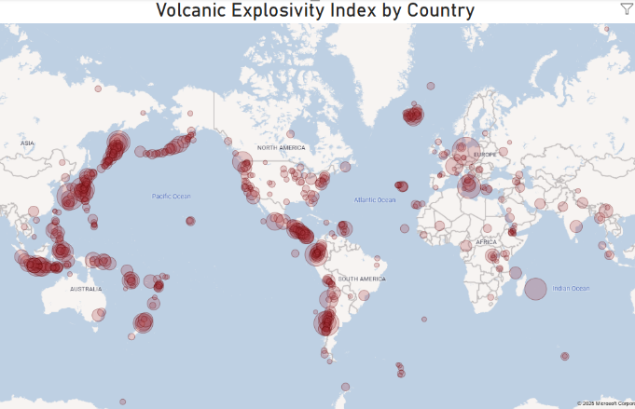Figure 4: VEI map.
The Top 10 volcanoes by VEI were also visualized in a bar chart as these indicate increase danger, although the top 10 was comprised of more VEI 6 volcanoes.

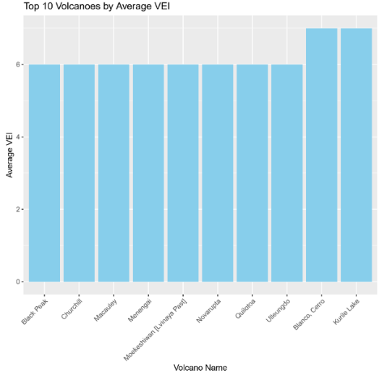
Figure 5: Top 10 volcanoes by VEI.
7. MODEL IMPROVEMENT/OPTIMIZATION

Q1: Explosive Eruption Classification
Five-fold cross-validation was conducted on the training set, optimizing for ROC AUC. Class imbalance was handled with and without SMOTE sampling.

Logistic Regression
- Alpha: {0.0 … 1.0}
- lambda:
coarse grid: 10^seq(-4, 1)
refined grid: seq(0.0001, 2.5)
final narrow grid: seq(0.001, 0.05)
- Best parameter: alpha = 0, lambda = 0.05.

Decision Tree (rpart)
- seq(0.000, 0.050, by = 0.005)

Random Forest (rf)
- {2, 15, 29, 42, 56}
- Best parameter: mtry =29

XGBoost (xgbTree) Grid:
- Nrounds = 100
- Eta = {0.05, 0.1, 0.3}
- max_depth = {2, 4, 6}
- Best parameter: eta = 0.30, max_depth = 6, nrounds = 100

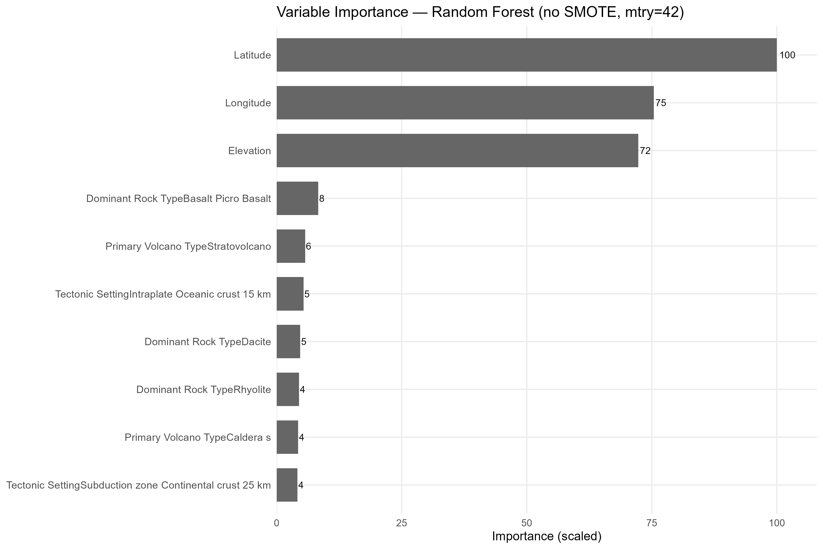
Figure 6: Feature importance of Random Forest.
The Random Forest feature importance shows latitude, longitude, and elevation as the strongest predictors of explosive eruptions, reflecting regional volcanic arc patterns. Rock type and volcano morphology (e.g., basalt, stratovolcano, caldera) also contribute, offering more interpretable geologic insights. This highlights a balance between spatial context and domain-specific traits in driving eruption predictions.

Q2: VEI Regression Modeling
To optimize model performance, we conducted 5-fold cross-validation on the training set, selecting hyperparameters that minimized RMSE.
Random Forest (RF)
- Number of features considered at each split (mtry): {2, 41, 81, 121, 161, 201, 241}
- Splitting criterion (splitrule): variance, extratrees}
- Minimum node size (min.node.size): 5
- Number of trees (num.trees): fixed at 500
- Best model: mtry = 41, splitrule = variance

XGBoost (XGB)
- Learning rate (eta): {0.05, 0.1}
- Maximum tree depth (max_depth): {3, 5, 7}
- Minimum child weight (min_child_weight): {1, 3}
- Number of boosting rounds (nrounds): 300
- Row subsampling (subsample): 0.8
- Column subsampling (colsample_bytree): 0.8
- Regularization term (gamma): 0
- Best model: eta = 0.1, max_depth = 3, min_child_weight = 1

7.1 Feature Importance Interpretation
Both Random Forest regression using elevation and tectonic setting as dominant predictors of VEI. Volcanoes in subduction zones and those at higher elevations are strongly associated with higher explosivity, consistent with volcanological theory. Geographic coordinates (latitude, longitude) also ranked highly, likely capturing regional volcanic arc effects (e.g., the Pacific Ring of Fire vs. intraplate settings).

Overall, these results indicate that VEI prediction is influenced by a combination of geodynamic context, spatial location, and intrinsic volcano characteristics.

Notably, one Random Forest regression model that included geographic coordinates achieved strong predictive performance, reflecting regional clustering of volcanic arcs. However, coordinates are less directly interpretable in a geophysical sense, as they primarily act as proxies for spatial context. In contrast, the model emphasizing e provides more scientifically interpretable insights, directly linking volcanological traits to eruption intensity. This highlights a common trade-off: models may gain predictive accuracy from location variables, but domain-specific features offer clearer explanations of eruption processes.

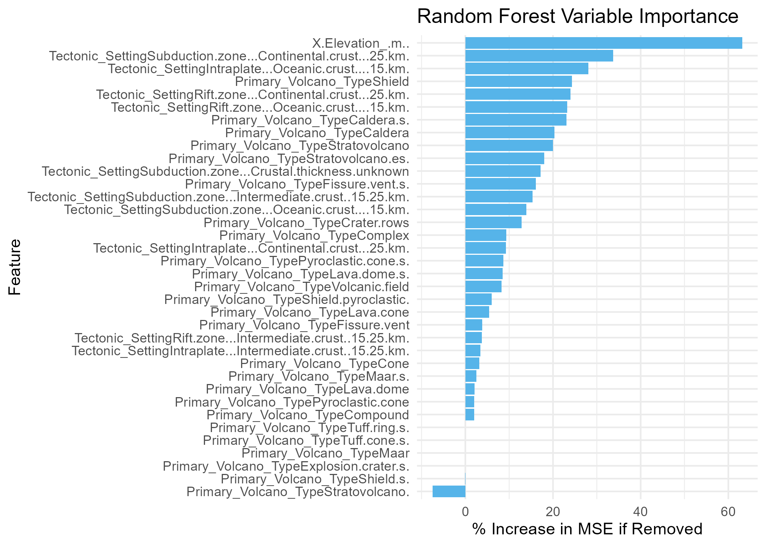
Figure 7: Feature importance of Random Forest Regression without Geo information.

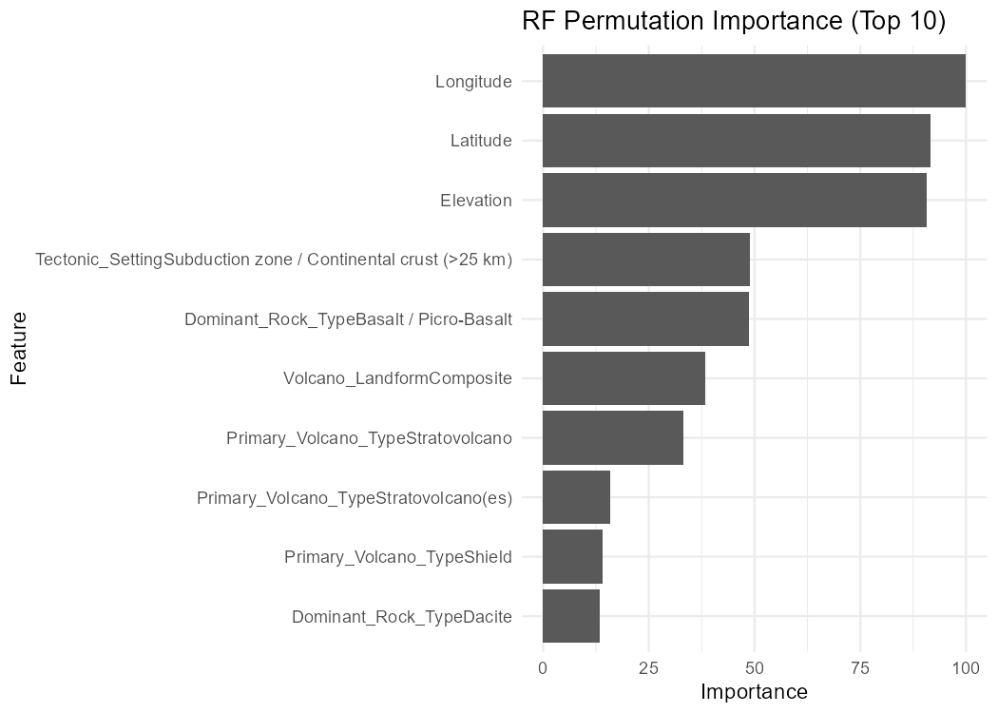Figure 8: Feature importance of Random Forest with Geo information.

8. REFERENCES

Bishop, C. M. (2006). Pattern recognition and machine learning. Springer.
Global Volcanism Program. (2024). Volcanoes of the World (Version 5.2.8; May 6, 2025) [Data set]. Smithsonian Institution. https://doi.org/10.5479/si.GVP.VOTW5-2024.5.2
Han, J., Kamber, M., & Pei, J. (2011). Data mining: Concepts and techniques (3rd ed.). Morgan Kaufmann.
James, G., Witten, D., Hastie, T., & Tibshirani, R. (2021). An introduction to statistical learning: With applications in R (2nd ed.). Springer.
Lantz, B. (2023). Machine learning with R (4th ed.). Packt Publishing.
Leskovec, J., Rajaraman, A., & Ullman, J. D. (2020). Mining of massive datasets (3rd ed.). Cambridge University Press.
McConnell, J., Thomas, K., Vo, Cuong (2025). DS520 Team Project: Volcanic Risk Modeling and Analysis (Version 1.0) [Computer software]. GitHub. https://github.com/janmcconnellCityU/DS520_Team_Project

